Windows System User Guide

First, download the executable JSON-to-Excel-LocalExcelAddin.exe from the provided link:
https://r2.wtsolutions.cn/j2e-releases/JSON-to-Excel-LocalExcelAddin-Windows-x64-6_1_0.exe

Create a new folder on your computer, place the downloaded .exe file into this folder, do not run the executable at this stage.

Right-click the folder, select Properties, enable sharing for the folder, and note down the network path. When configuring network access permissions, make sure you have both read and write permissions​ for the folder.

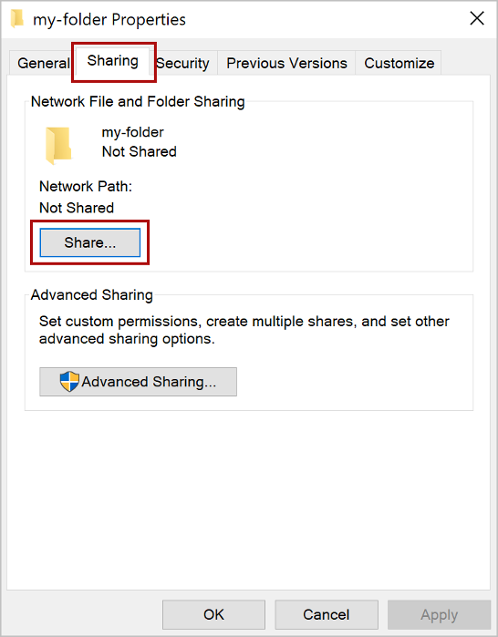
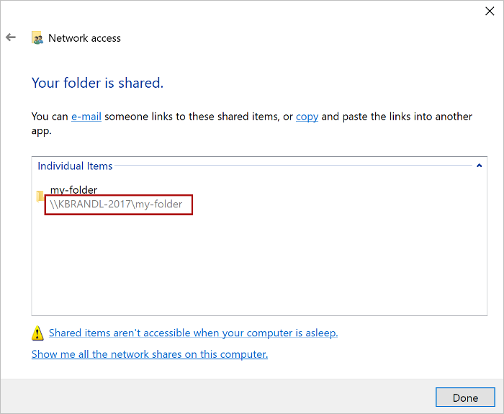
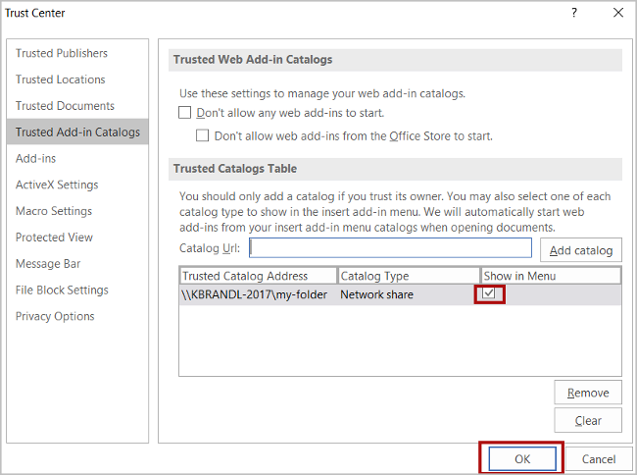

Configure Excel Trusted Add-in Directory
- Open Excel, go to the File tab → select Options.
- Navigate to Trust Center→ click Trust Center Settings.
- Select Trusted Add-in Catalogs.
- In the Catalog URL​ input box, paste the full network path of the shared folder you obtained earlier. If you forget the path after enabling sharing, you can also check it via the JSON-to-Excel-LocalExcelAddin program.
- Click Add Catalog after entering the path.
- Check the Show in Menu​ checkbox for the newly added item, then click OK.
- Close all Excel workbooks completely, then reopen Excel to apply the configuration.

All above is a one-time setup and does not need to be repeated later.
Below steps shall be performed each time

Launch the Add-in
- Make sure all open Excel workbooks are saved and closed first, then run JSON-to-Excel-LocalExcelAddin.exe.
- If the program prompts that Excel can be opened to sideload the add-in:
  - Open Excel, go to the Home tab → find the add-ins entry → click More Add-ins​ at the bottom right.
  - At the top of the pop-up window, switch to the Shared Catalogs / Shared Folders tab, click the Refresh​ button in the upper right corner.
  - The JSON-to-Excel-LocalExcelAddin add-in will appear in the list. Select it and click Add​ at the bottom right.
- After successful installation, a new button for JSON-to-Excel-LocalExcelAddin will show up at the right of the Excel Home tab. Click it, and the localized add-in will load on the right side of Excel.

Questions? Email he.yang@wtsolutions.cn
Documentation of JSON-to-Excel at https://JSON-to-Excel.wtsolutions.cn

